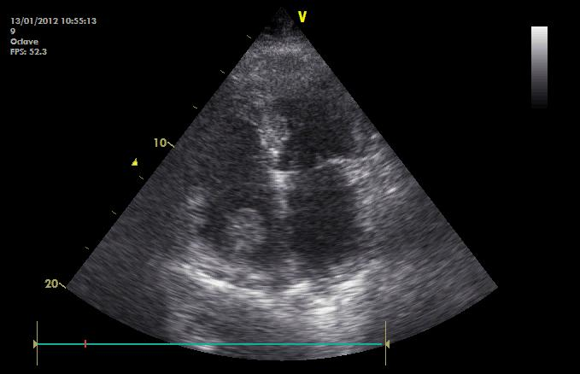
Figure 1. Thromboembolus in the right atrium, adhering to the pacing catheter.

