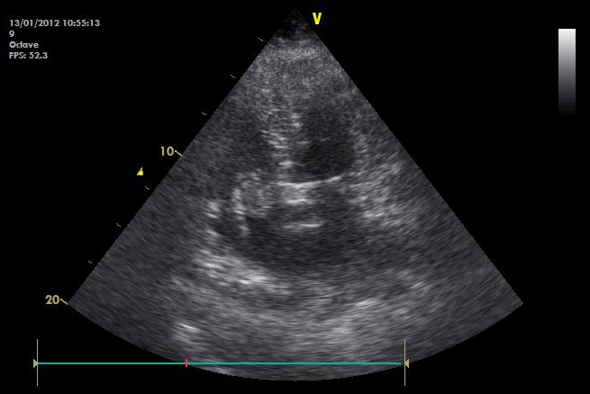
Figure 2. Mobile thromboembolus, serpentinuous, prolapsing through the tricuspid valve.

