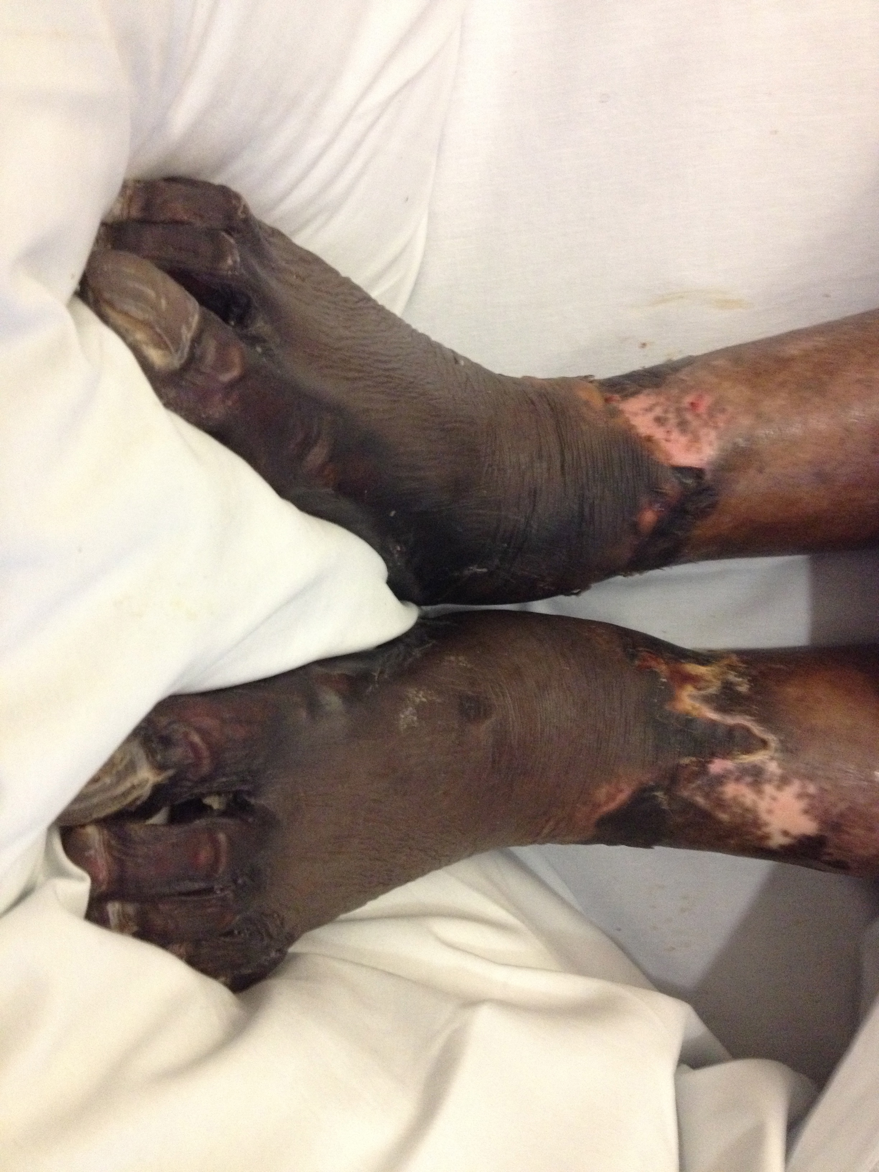
Figure 1 showing purpura fulminans leading to peripheral gangrene in the feet.

