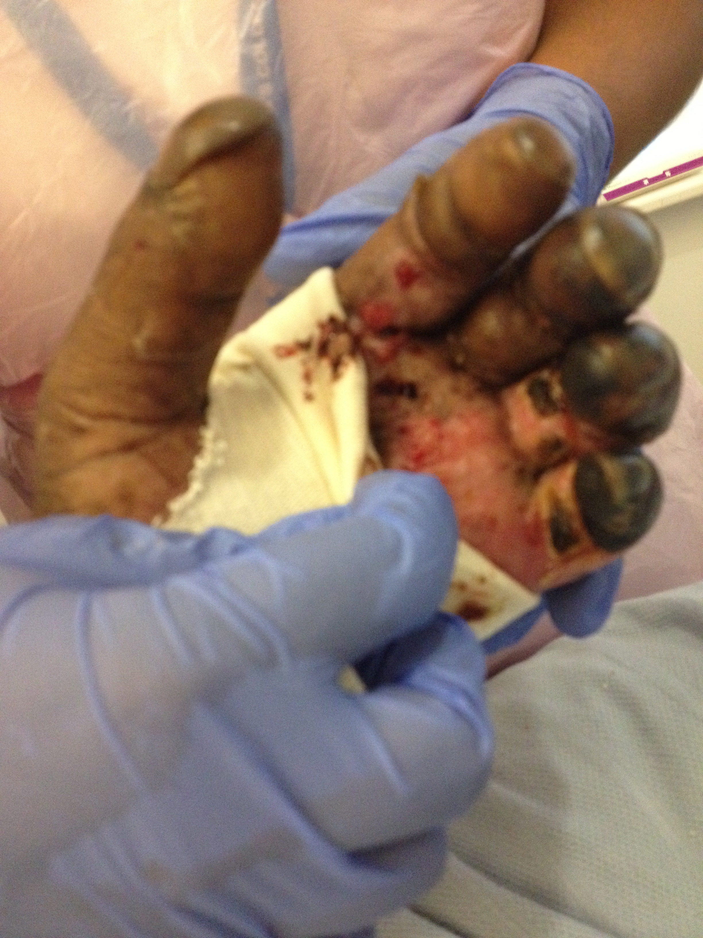
Figure 2 showing purpura fulminans leading to peripheral gangrene in the hands.

