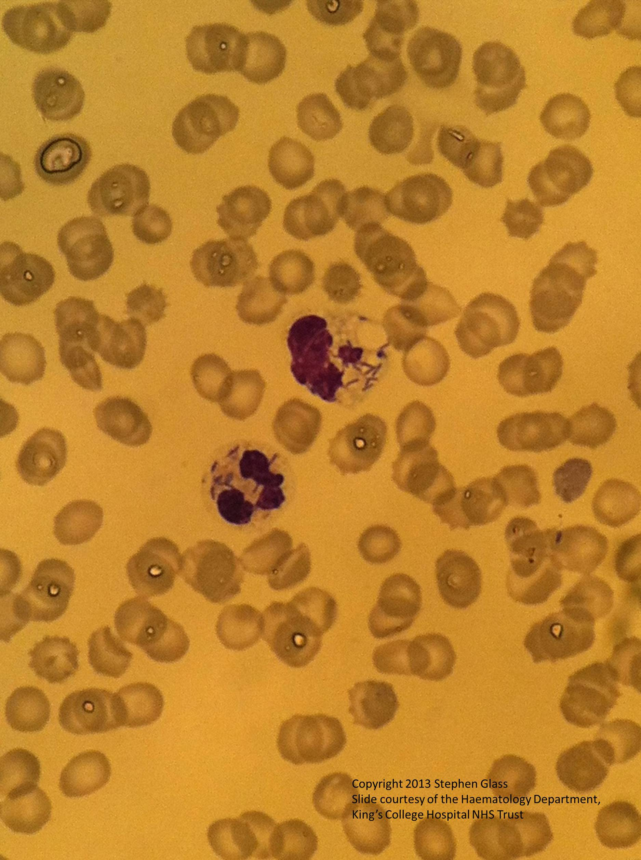
Figure 3 A peripheral blood smear showing intracellular bacilli in neutrophils

